Assignment 1:

INTRODUCTION
As a new Prime Minister, my first responsibility is to protect Canada from the environmental issues that people face in their day-to-day lives. Transportation plays an important part in our daily lives. In this scenario, transportation is the major concern in Canada because a large amount of gas emissions is produced by it.
I chose this topic because I checked that the number of vehicles is increasing on the highways and in cities, which significantly affects the environment. Transportation affects every Canadian daily. According to the Government of Canada, Canada’s GHG emissions increased by 14.4% between 1990 and 2023. It is mentioned that climate change is caused by the increasing level of greenhouse gas emissions in the atmosphere.
The main purpose of this document is to reduce greenhouse gas emissions in Canada, and its solutions are based on research, such as improving public transport and promoting electric vehicles. As the scientific research on oil and gas/transportation was the top emitters at 30% and 23% of total emission respectively, in Canada. Greenhouse gas emissions negatively affect the environment, such as rising temperatures, poor air quality, and pollution, along with human health.

METHODS
Environmental variables are measured through national surveys, environmental assessments and scientific research to track climate change impacts, such as the Households and Environment Survey (HES) (canada, Households and Environment Survey, 2025).
According to Wikipedia, climate change is the result of greenhouse gas emissions, which are produced by human activities. In 2017, 24% of Canada’s greenhouse gas came from trains, trucks and cars.
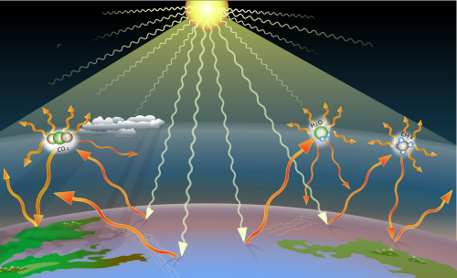
Figure 1: Greenhouse gas emissions
Greenhouse gases trap some of the heat that results when sunlight heats the Earth's surface. Three important greenhouse gases are shown symbolically in this image: carbon dioxide, water vapor and methane (Wikipedia, 2026).
As Prime Minister, I would encourage national policies that promote the use of electric vehicles and improve public transportation across the country. The government would provide financial incentives, such as tax credits, to make electric vehicles more affordable. The government would also invest in building the infrastructure for electric vehicles, including charging stations along highways, at apartment buildings, at workplaces, and in public areas.
Along with that, I would prioritize public transportation, which also plays a crucial role in reducing environmental impact. In large cities, there are many traffic issues. Electric public transit produces fewer emissions than private vehicles and reduces traffic congestion.

RESULTS
The use of electric vehicles changes the ratio of greenhouse gas emissions. The adoption of a zero-emission vehicle (ZEV) is more affordable compared to driving with gas or diesel. According to the experts, after 10 years, the overall savings can be significant. The studies show that Clean Energy Canada compared the total cost of ownership. 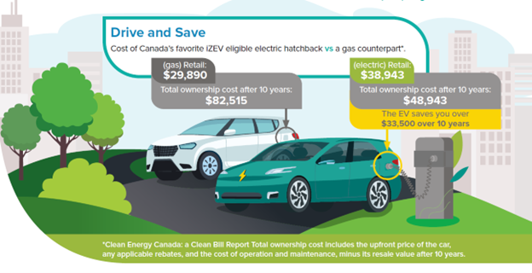
Figure 2: Comparison between gas retail and electric retail (canada, Zero emission vehicles benefits of driving, 2025).

The latest statistics of Canada report indicate that ZELDV registrations in 2024 account for 14.47%. The figure below shows the distribution of LDV (light-duty vehicle) registrations in Canada. Based on the figure below, it is proven that the transition to ZEVs has been initiated in Canada.

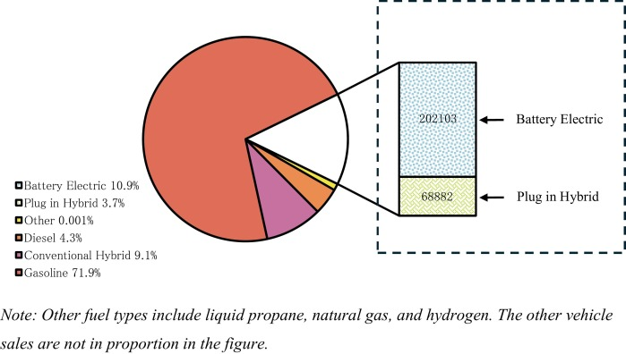
Figure 3: Canadian new LDV registrations distribution based on fuel type -2024 (Nipun Kumarage, 2025).

According to research by the World Bank, I found that EV sales have been increasing quickly over the years. The growing need for green energy technologies, such as electric vehicles and renewable energy, is needed to generate electricity. The production of lithium and cobalt will need to rise by 500% by 2050. (Snel, 2023)

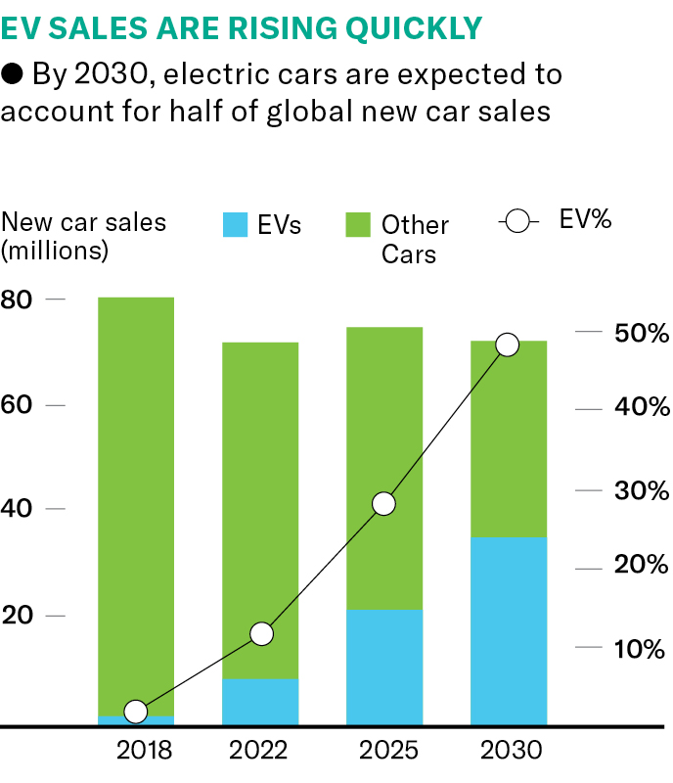
Figure 4: EV sales (Snel, 2023)

Worldwide production of lithium like silvery metal used in battery manufacturing.
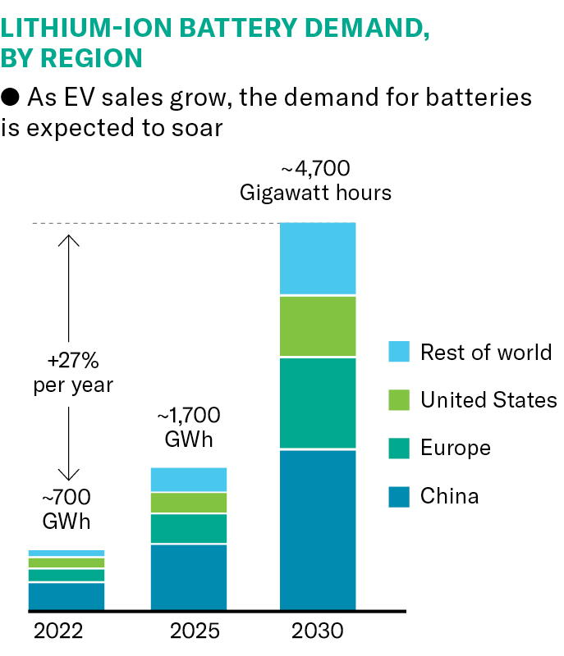
Figure 5: Chart source: McKinsey Battery insights (Snel, 2023)

DISCUSSION
Scientific studies show that the US would need 90 % of all passenger vehicles on the road to be electric, around 350 million vehicles, by 2050. For instance, in a state like coal-dependent West Virginia, an electric vehicle will produce roughly 6% more greenhouse gases during its lifetime than a gas-powered vehicle of the same size when manufacturing emissions are taken into consideration.
“Solar and wind have gotten much cheaper than they used to be. These are not prohibitively expensive technologies anymore”, Posen says. (Snel, 2023)
The solution to this environmental issue is the reduction of greenhouse gas emissions, which encourages people to use eco-friendly products daily and supports the government to reduce the environment condition. The government of Canada is taking bold and immediate actions to reduce greenhouse gas emissions to fight climate change with clean air, good jobs and a healthy environment.
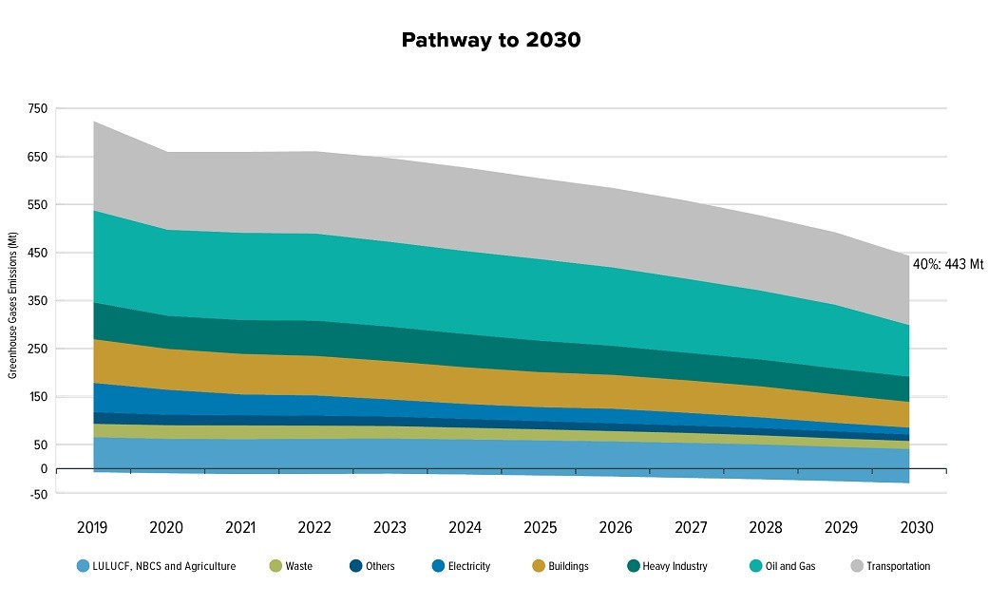
Figure 6: Pathway of 2030 (canada, 2030 Emissions Reduction Plan: Clean Air, Strong Economy, 2025)

Bibliography
canada, G. o. (2025, December 2025). 2030 Emissions Reduction Plan: Clean Air, Strong Economy. Retrieved from https://www.canada.ca/en/services/environment/weather/climatechange/climate-plan/climate-plan-overview/emissions-reduction-2030.html
canada, G. o. (2025, 12 09). Households and Environment Survey. Retrieved from https://www150.statcan.gc.ca/n1/daily-quotidien/251209/dq251209d-eng.htm
canada, G. o. (2025, 06 12). Zero emission vehicles benefits of driving. Retrieved 04 02, 2026, from https://www.canada.ca/en/services/transport/zero-emission-vehicles/benefits-of-driving-a-zero-emission-vehicle.html
Nipun Kumarage, K. H. (2025). Canada's transion to light-duty zero emission vehicles. ScienceDirect, 199(https://www.sciencedirect.com/science/article/pii/S0965856425002393).
Snel, P. (2023, November 30). Can Electric vehicles save the planet? (Civil & Mineral Engineering University of Toronto) Retrieved Febuary 04, 2026, from https://civmin.utoronto.ca/can-electric-vehicles-save-the-planet/
Wikipedia. (2026, 02 04). Greenhouse gas. Retrieved from https://en.wikipedia.org/wiki/Greenhouse_gas

